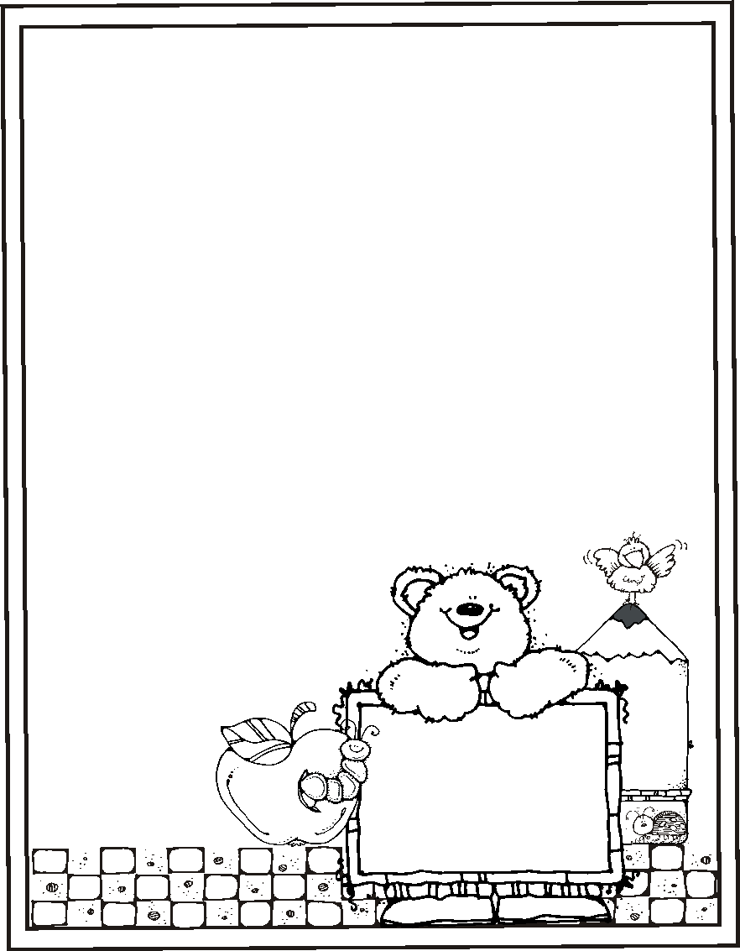

EVERGREEN HEIGHTS 2020-2021

KINDER HYBRID SUPPLY LIST

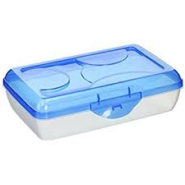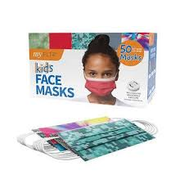

* Plastic Pencil Box (1) (Write Name)
* 16 OR 24 box of crayons (2)
* BLACK Expo Markers (6)
* Glue Sticks (12)
* Scissors (1) (Write Name)
* Extra Mask (2) (Write Name)
* 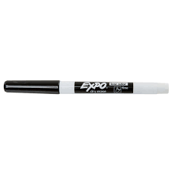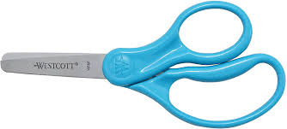Double-pocket folder (3) (Write Name)
* Big Erasers (2)
* Jumbo Pencils (6)
* Water Color Set (1) (Write Name)

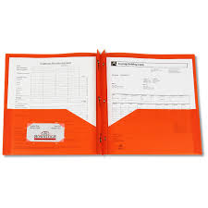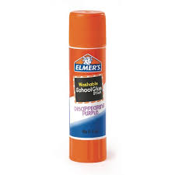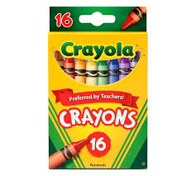

**Welcome**

**Kindergartener’s**